1) Configure VPC peering in cross regions.

Create VPC on different regions A and B.  
In region_A to create VPC peering  
send a request to another region_B  
Then the region_B accept the region_A request.

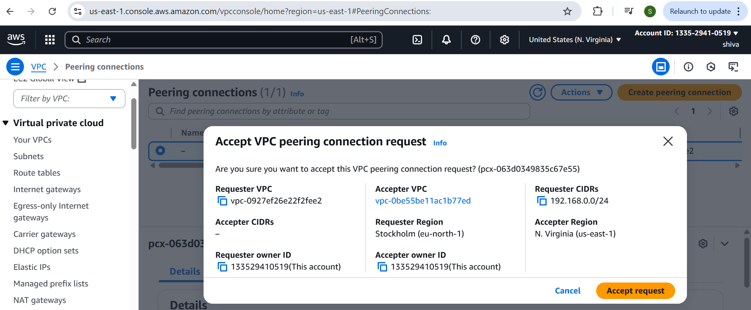

In both the regions go to Route table to edit route

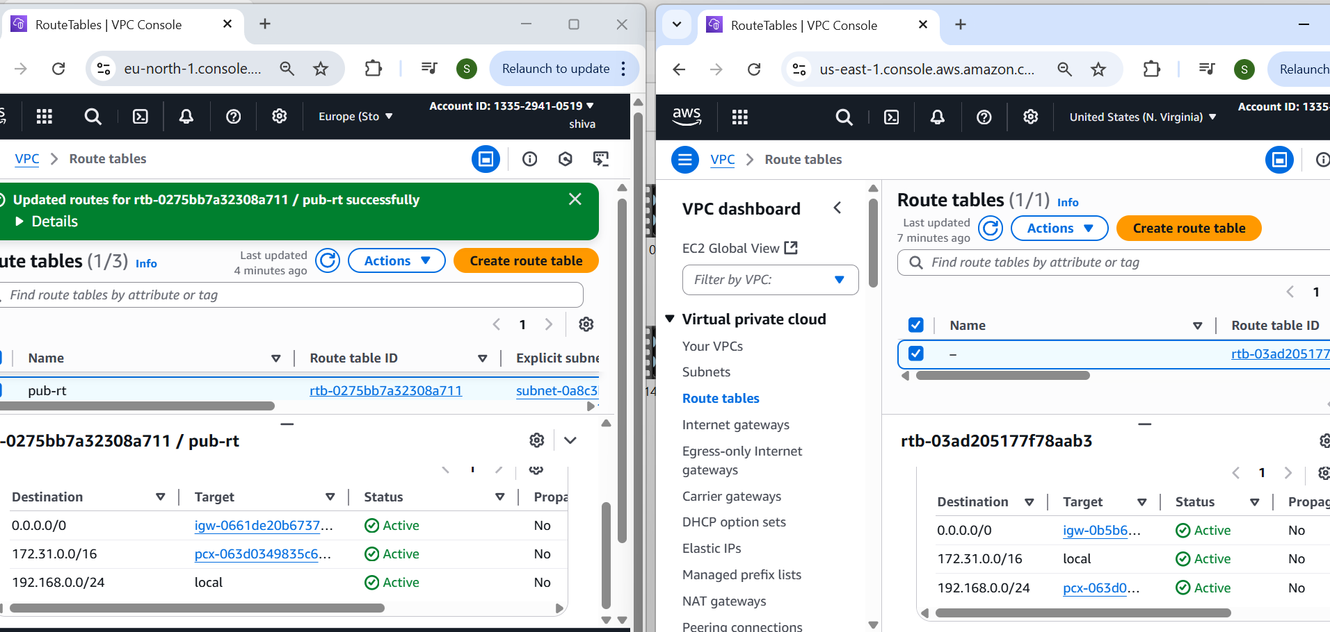

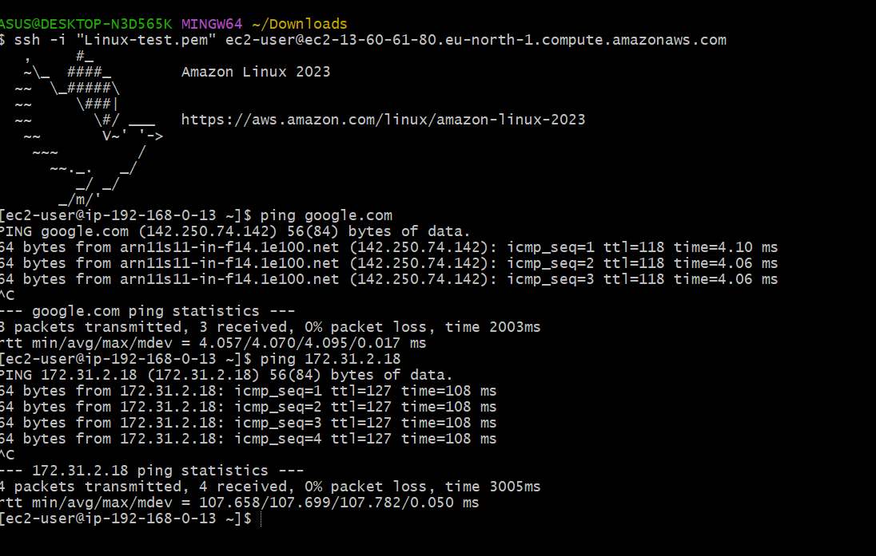

2) Purchase one domain from godaddy.

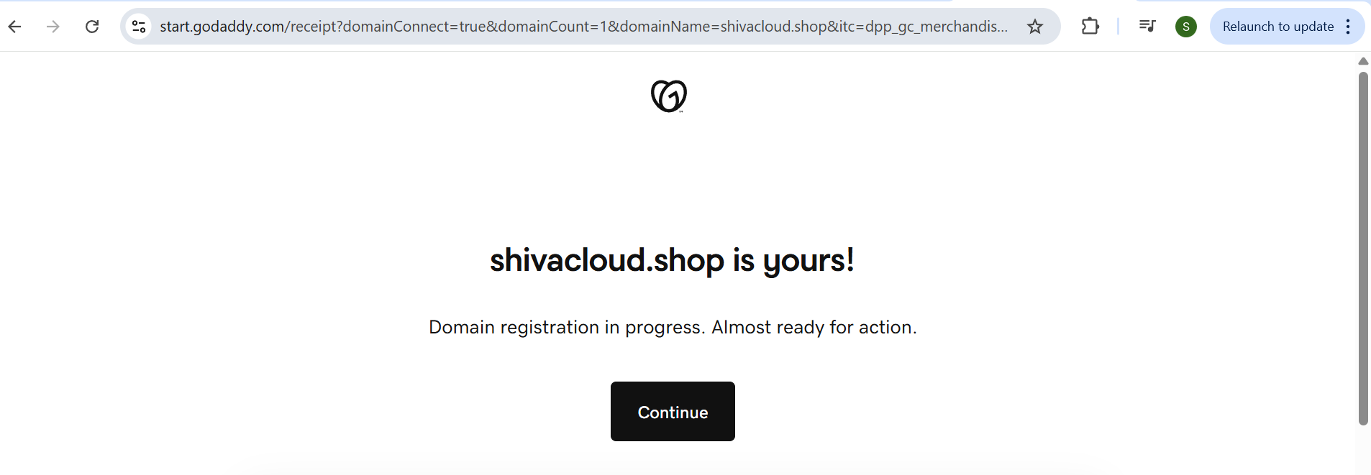

3) Deploy static webiste in s3.

Upload website files to s3  
S3 ---> Buckets ---> select the bucket ---> objects ---> upload ---> Add   
website files ---> upload

Select created files ---> Actions ---> make public using ACL ---> make   
public  
To enable static website hosting  
 S3 ---> Buckets ---> select the bucket ---> properties ---> Static website   
hosting(enable) ---> Set index and error documents ---> save changes

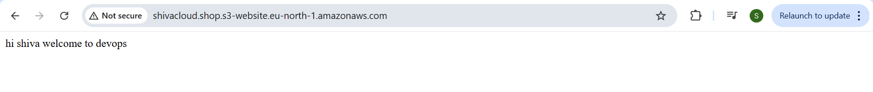

4) Create CDN and attach one SSL certificate.

STEP:1  
Create a s3 bucket and deploy static website.  
STEP:2  
Create a CloudFront Distribution.

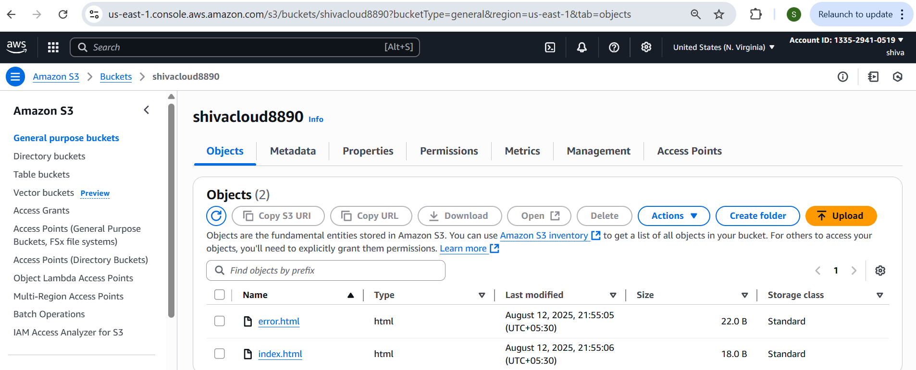

Create a CloudFront Distribution.  
CloudFront ---> Distributions ---> Create distribution

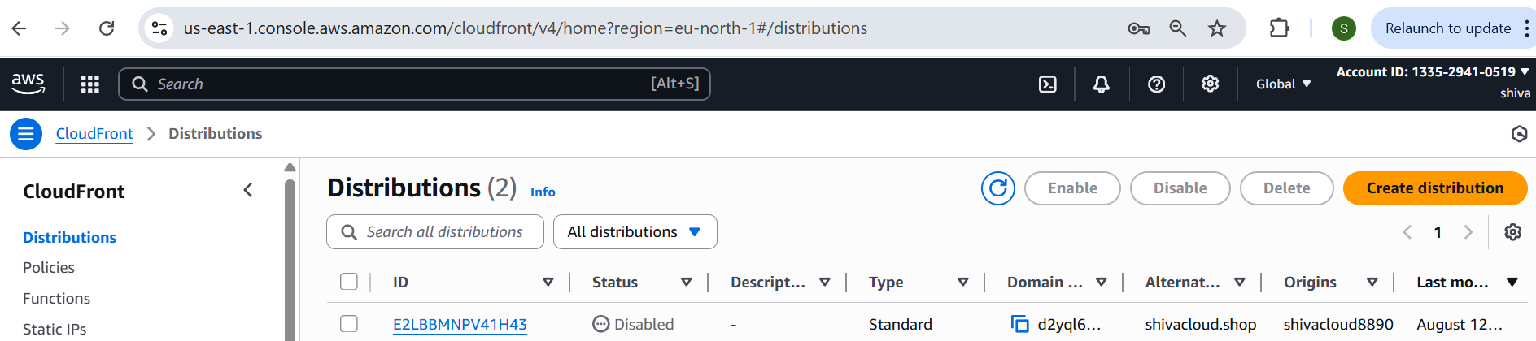

Attach SSL Certificate  
CloudFront ---> Distributions ---> click created distribution --->click edit in  
settings

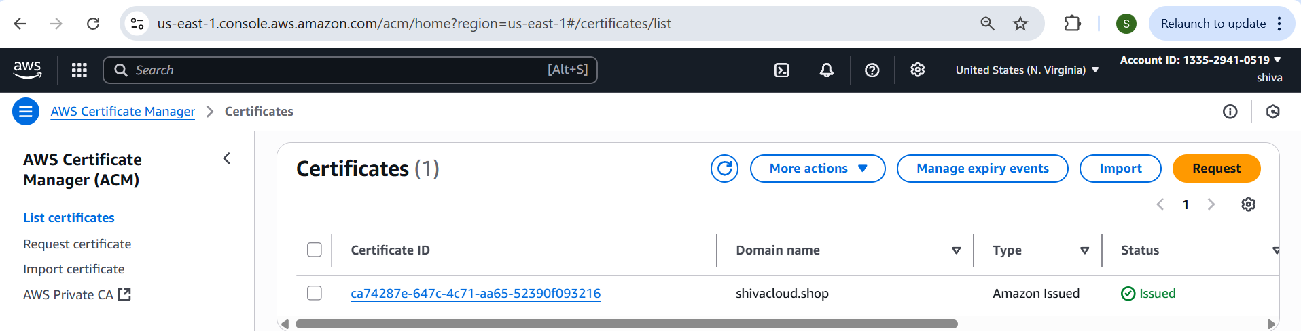

5) Create Route53 hosted zone and MAP the domain with CDN.

STEP:1  
To create hostedzone  
Route53 ---> Hostedzone ---> click Create hosted zones --->  
Enter Domain name(shivacloud.shop) ---> click create hosted zone

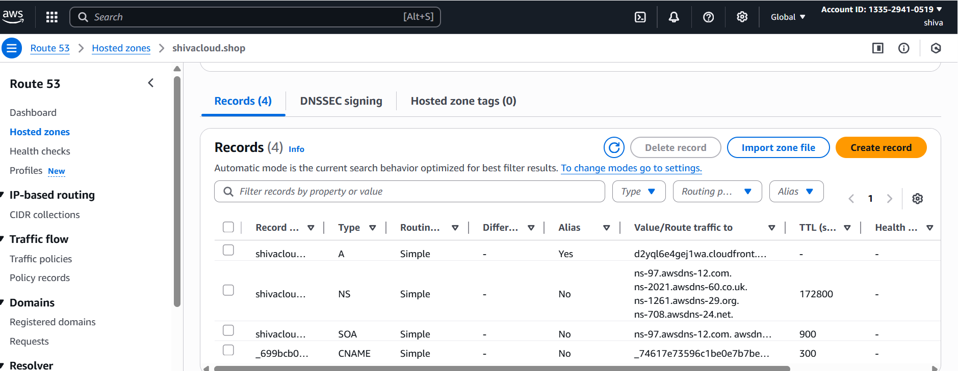

Add these servers to daddy from created hostzone

Go to Godaddy ---> My Products ---> select your domain(shivacloud.shop)  
---> Manage domain ---> DNS ---> Nameservers ---> ChangeNameservers  
---> I'll use my own nameservers ---> add servernames from Route53   
created hostzone

6) Update the index.html in s3 bucket and the updated file should be accessible by using domain name.

Upload index.html in s3 bucket and Make Public using ACL

CloudFront ---> Distributions ---> your distribution ---> Invalidation --->   
create invalidation

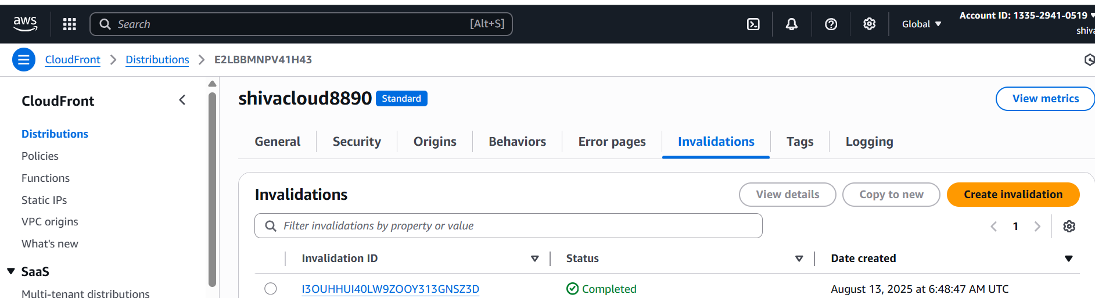

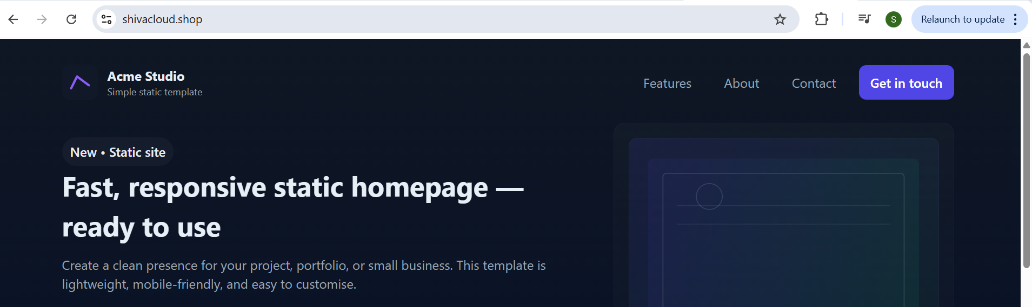

7) Share the Domain name in slack to test the connetivity.

Shivacloud.shop